**Name: Prajwal Bawner**

1. Using features of Java 11, read the data from a text file (File name: StudentList.txt).

Calculate the count of students and print the names as well as the total count of

students on the screen. (If any line in file doesn’t contain a name, for such a record

blank space should not be printed in the output)

Hint: Use java 11 features of files and String methods to reduce the lines of code to

be written.

**Code:**

import java.io.*;  
import java.util.Scanner;  
  
public class Assignment3Q1 {  
 public static void main(String[] args) throws IOException {  
 *// File path is passed as parameter* File file = new File("C:\\Users\\07ayu\\Documents\\Capgemini\\Java Core 11\\Java11Assignments_StudentList.txt");  
  
 Scanner sc = new Scanner(file);  
  
 int count = 0;  
 while (sc.hasNextLine()){  
 String string = sc.nextLine();  
  
 if(string.length()!=0){  
 System.out.println(string.trim());  
 count++;  
 }  
 }  
 System.out.println("Total number of students present in the txt file are: "+count);  
  
 sc.close();  
 }  
}

**Output:**

Java11Assignments_StudentList.txt file

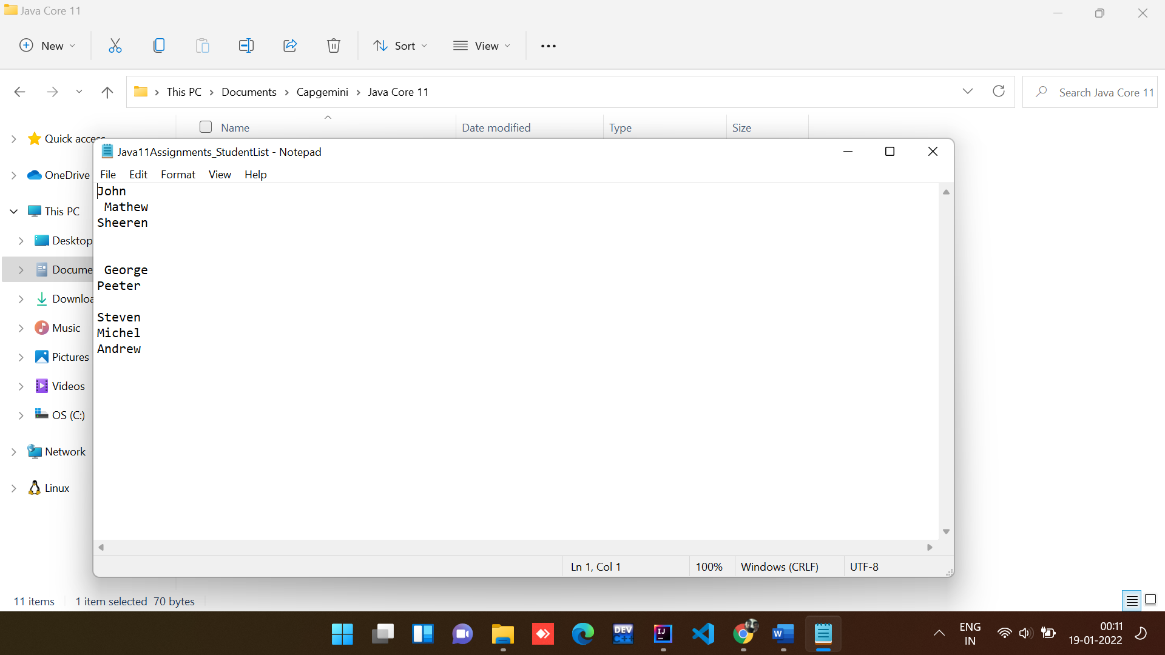

Java code ouput:

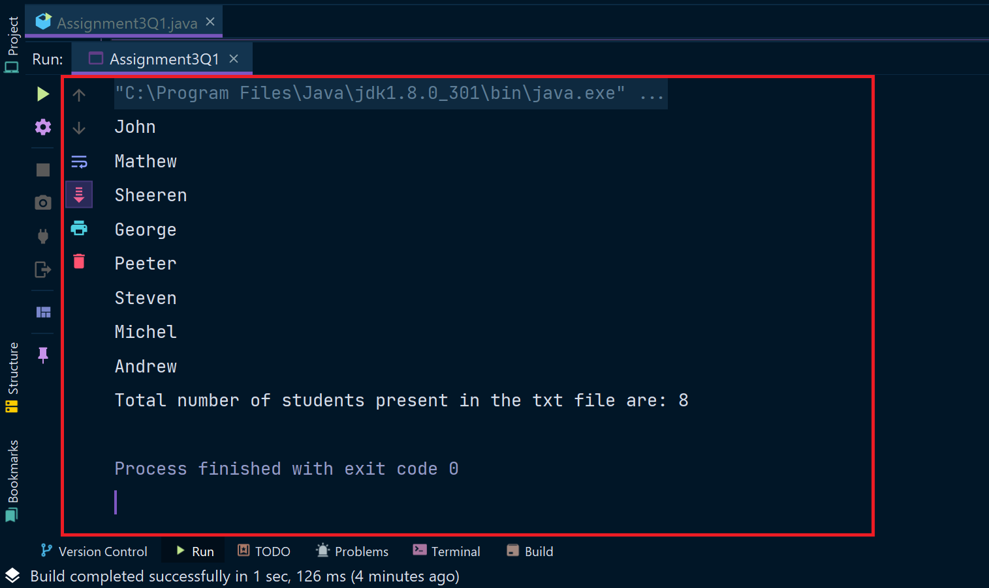

2. Write a program with menu to accept the price of certain items and display their total.

When user selects Option 1: should accept the prices of different products and insert

these prices into first file (each amount to be inserted in a newline in the file). Next,

total of these values should be saved in a new file. Option 2: should allow the user to

view the total of these prices from the second file.

Sample Output:

Select your option (1: Insert New Price, 2: View Purchase Total, 3: Exit)

> 1

> Insert 1st price:

> 100

> Price has been saved to the file

> Do you want to enter price for more items? (Yes/No)

> Yes

> Insert 2nd price:

> 200

> Price has been saved to the file

> Do you want to enter price for more items? (Yes/No)

> No

> Select your option (1: Insert New Price, 2: View Purchase Total, 3: Exit)

> 2

> Total Price of all items is: 300

> Select your option (1: Insert New Price, 2: View Purchase Total, 3: Exit)

> 3

exit program….

Hint: Use java 11 features of files and String methods to reduce the line of code.

**Code:**

import java.util.Locale;  
import java.util.Scanner;  
  
public class Assignment3Q2 {  
 public static String ordinal(int i) {  
 String[] suffixes = new String[]{"th", "st", "nd", "rd", "th", "th", "th", "th", "th", "th"};  
 switch (i % 100) {  
 case 11:  
 case 12:  
 case 13:  
 return i + "th";  
 default:  
 return i + suffixes[i % 10];  
  
 }  
 }  
 public static void main(String[] args) {  
 Scanner sc = new Scanner(System.in);  
 int count = 0;  
 int price,total = 0;  
 int choice;  
  
 do{  
 System.out.println("\t\t******************************\t\t");  
 System.out.println("\t\t** 1) INSERT NEW PRICE **\t\t");  
 System.out.println("\t\t** 2) VIEW PURCHASE TOTAL **\t\t");  
 System.out.println("\t\t** 3) EXIT **\t\t");  
 System.out.println("\t\t******************************\t\t");  
 System.out.print("\t\tENTER YOUR CHOICE: ");  
 choice = sc.nextInt();  
 switch (choice){  
 case 1:  
 String s = "Yes";  
 do{  
 System.out.print("\t\tInsert "+*ordinal*(count+1)+" price: ");  
 price = sc.nextInt();  
 total += price;  
 System.out.println("\t\tPrice has been saved to the file");  
 System.out.print("\t\tDo you want to enter price for more items? (Yes/No): ");  
 s = sc.next();  
 count++;  
 System.out.println();  
 }while(s.equalsIgnoreCase("Yes"));  
 break;  
 case 2:  
 System.out.println("\t\tTotal Price of all items is: "+total);  
 break;  
 case 3: System.*exit*(0);  
 default : System.out.println("\t\tPLEASE ENTER THE CORRECT CHOICE!");  
 }  
 }while(choice!=3);  
  
 }  
  
  
}

**Output:**

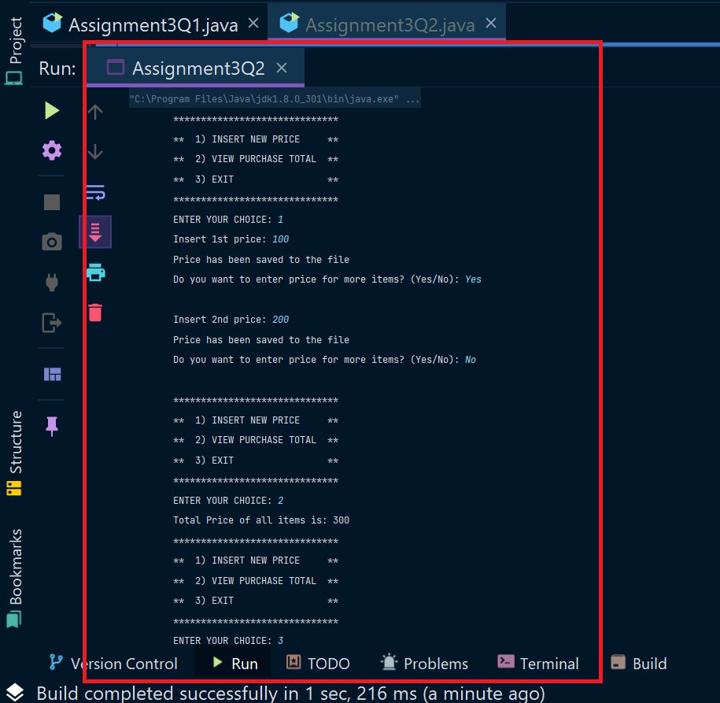

3. Write a code using HttpClient API which sends a GET request

to https://httpbin.org/get, and print out the response header, status code, and

body for the given URL.

Sample output could be (Note: date and other attribute values may differ in your

results):

access-control-allow-credentials:[true]

access-control-allow-origin:[*]

connection:[keep-alive]

content-length:[273]

content-type:[application/json]

date:[Fri, 06 Aug 2021 13:07:41 GMT]

server:[gunicorn/19.9.0]

200

{

"args": {},

"headers": {

"Content-Length": "0",

"Host": "httpbin.org",

"User-Agent": "Java 11 HttpClient Bot",

"X-Amzn-Trace-Id": "Root=1-610d341d-092dc33f698b192a219426d1"

},

"origin": "43.255.221.184",

"url": "https://httpbin.org/get"

}

Code:

import java.io.*;  
import java.net.*;  
import java.util.ArrayList;  
import java.util.Date;  
import java.util.HashMap;  
import java.util.*List*;  
import java.util.*Map*;  
  
public class Assignment3Q3 {  
 public static void main(String[] args)  
 {  
 try  
 {  
 URL url = new URL("https://httpbin.org/get");  
  
 *//open the connection to the above URL.* HttpURLConnection http = (HttpURLConnection)url.openConnection();  
 URLConnection urlcon = url.openConnection();  
 *Map*<String, *List*<String>> header = urlcon.getHeaderFields();  
  
 *//print all the fields along with their value.* for (*Map*.*Entry*<String, *List*<String>> mp : header.entrySet())  
 {  
 System.out.print(mp.getKey() + " : ");  
 System.out.println(mp.getValue().toString());  
  
 }  
 System.out.println("\nGet Response Header By Key ...");  
 *List*<String> contentLength = header.get("Content-Length");  
 if (contentLength == null) {  
 System.out.println("'Content-Length' doesn't present in Header!");  
 } else {  
 for (String header1 : contentLength) {  
 System.out.println("Content-Lenght: " + header1);  
 }  
 }  
  
 int statusCode = http.getResponseCode();  
 System.out.println("Status Code: "+statusCode);  
  
 System.out.println();  
 System.out.println("Complete source code of the URL is-");  
 System.out.println("---------------------------------");  
  
 *//get the inputstream of the open connection.* BufferedReader br = new BufferedReader(new InputStreamReader  
 (urlcon.getInputStream()));  
 String i;  
  
 *//print the source code line by line.* while ((i = br.readLine()) != null)  
 {  
 System.out.println(i);  
 }  
 }  
  
 catch (Exception e)  
 {  
 System.out.println(e);  
 }  
 }  
}

Output:

